***Discrete Math*. Handwriting Assignment #5**

**Due to 8th/June**

1. **Are the following two graphs isomorphic?**



1. **Find the adjacency matrix for the following graph**



1. **Give the transitive closure of the following graph  
   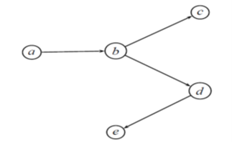**
2. **Answer the questions for the following tree.  
   a) What is the height of T? b) List all of the leaves of T.  
   c)List all of the siblings of d. d)** **List all of the descendants of d.**

